Children’s Feedback Form
Name |  | Date
Colour or circle the face that best describes what you think.
 | Good | Ok | Bad
Your First Session | 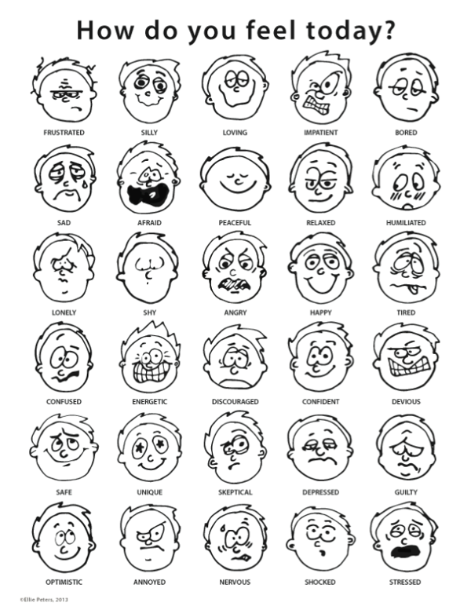
Toys and Games
Our Staff
Our Building

Your Thoughts

