Children’s Feedback Form
Your Name |  | Date
Colour or circle the face that best describes what you think
 | Amazing | Good | Ok’ish | Bad | Terrible
How well did we help you to prepare for this service before the first session? | 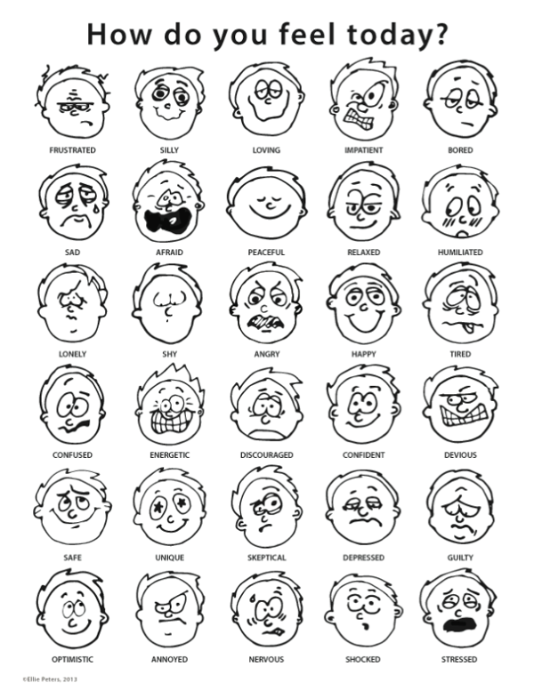
How good were our toys, games, and activities?
How friendly and helpful were our staff?
How clean and tidy was our building?

Is there anything else you want to tell us?

